Lance Tran
CS 255
Feb 28 2026

CS 255 System Design Document

This template lays out all the different sections that you need to complete for Project Two. Each section has guidance to prompt your thinking. You will need to continually reference the interview transcript as you work to make sure that you are addressing your client’s needs. There is no required length for the final document. Instead the goal is to complete each section based on what your client’s needs are. Remove this note when you are finished, and replace all bracketed text with the relevant information.

UML Diagrams

UML Use Case Diagram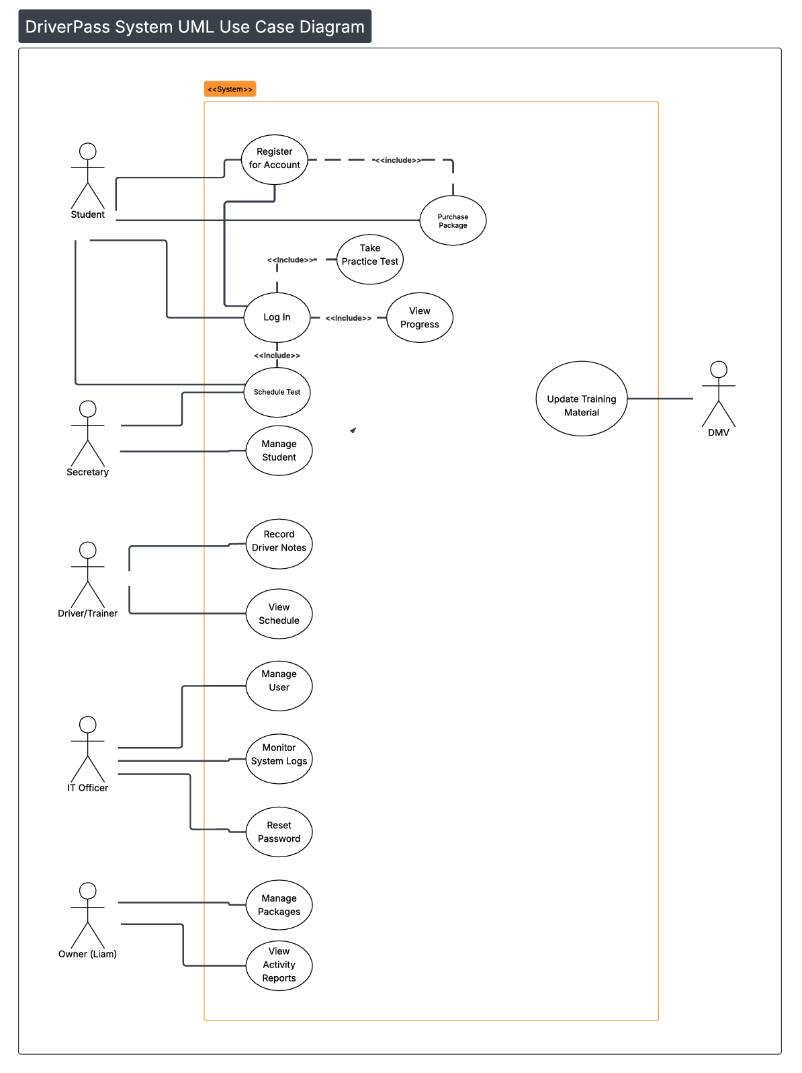

UML Activity Diagrams
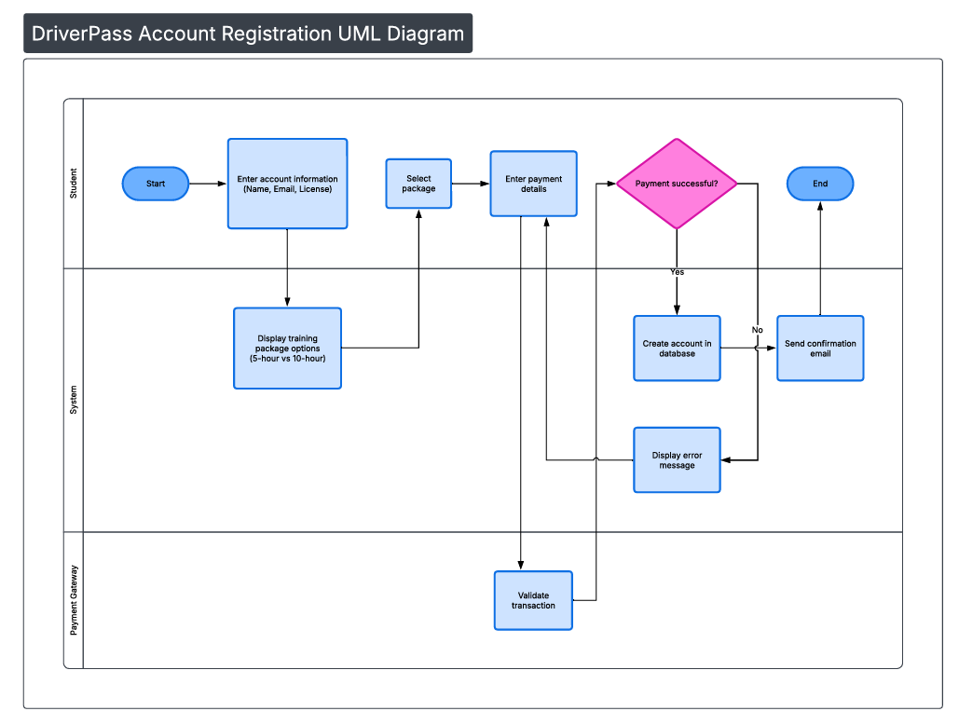
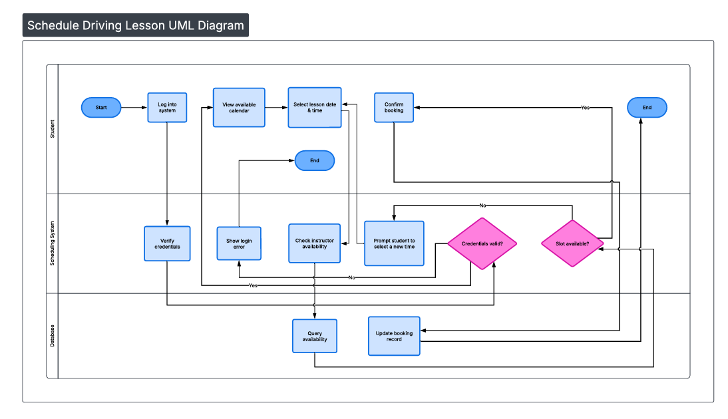

UML Sequence Diagram
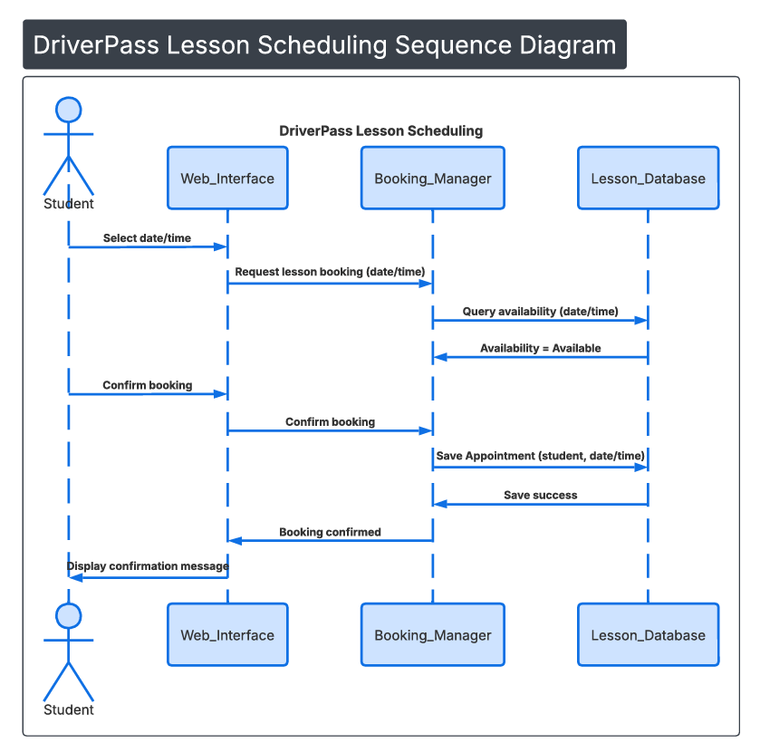

UML Class Diagram
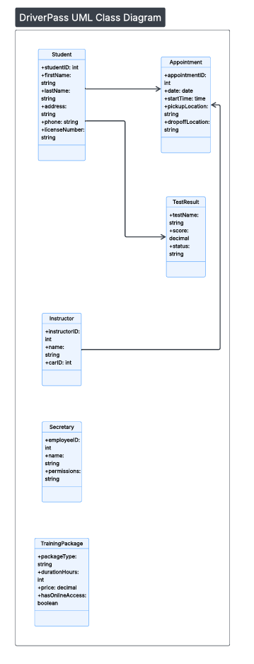

Technical Requirements

System Components and Design

Purpose
What is the purpose of this project? Who is the client and what do they want their system to be able to do?
- The project purpose is to build a comprehensive training and management system for a new driving school, DriverPass.
- The client is DriverPass, represented by Liam (Owner) and Ian (IT Officer).

System Background
What does DriverPass want the system to do? What is the problem they want to fix? What are the different components needed for this system?
- The problem being solved is: DriverPass wants to replace the manual management of students, instructors, and vehicles to solve logistical difficulties and the lack of standardized training.
- The system components has to include a web/cloud-based interface, database, scheduling module and a training module.
- The system will be used by the Owner (Liam), IT Officer (Ian), Secretaries, Drivers/Trainers, and Students.

Objectives and Goals
What should this system be able to do when it is completed? What measurable tasks need to be included in the system design to achieve this?
- The primary goal is to address high DMV driving test failure by offering structured, affordable and accessible online classes, practice tests and practical training.
- The system must provide online/offline data access, track all changes for accountability, and handle online registration, scheduling, and training progress.
- When finished, the system will allow students to register, pay, and schedule lessons online, while also tracking their progress and driver notes.
- The primary design will revolve around measurable tasks. Key tasks include collecting requirements, creating diagrams (use case, activity, class), designing the UI, linking the database, and implementing business logic for security and roles.

Requirements

Nonfunctional Requirements

Performance Requirements
- Environments: The system needs to run in a web-based/cloud environment to allow access from anywhere, as specified in the project summary. It should be accessible via standard web browsers on desktops and mobile devices.
- Speed: To meet the responsiveness requirement, the Booking Manager (Controller) must process availability queries to the Lesson Database (Entity) in under 500ms. This leaves a margin to ensure the Web Interface completes the full scheduling sequence within the 3-second user experience threshold.
- Updates: The system should be updated regularly to incorporate new DMV regulations and security patches. A monthly or quarterly update cycle would be appropriate, with critical security updates deployed immediately.

Platform Constraints
- Platforms: As a web-based application, the system should be platform-agnostic. Therefore, it should have a client-server architecture. The clients can be a responsive web app compatible with all modern browsers, allowing support on any device that supports a standard web browser.
- Back-End Tools: Yes, the system will utilize a Relational Database Management System (RDBMS) such as MySQL or PostgreSQL. This will store the data structures defined in the UML Class Diagram, specifically the Student, Appointment, and TrainingPackage entities."

Accuracy and Precision
- User Distinction: The system will distinguish between users via a unique login credential (e.g., username or email address) and a password. User roles (Owner, IT Officer, Secretary, Driver, Student) will further define their access and permissions.
- Case-Sensitivity: Usernames and passwords should be treated as case-sensitive to enhance security.
- Admin Notification: The system infrastructure will include an SMTP (Simple Mail Transfer Protocol) gateway to trigger immediate email alerts to the Admin/IT Officer, upon detecting repeated failed login attempts or database connection timeouts, ensuring the 'Accuracy and Precision' requirement is maintained.

Functional Requirements
Using the information from the scenario, think about the different functions the system needs to provide. Each of your bullets should start with “The system shall . . .” For example, one functional requirement might be, “The system shall validate user credentials when logging in.”
- The system shall validate user credentials (username/email and password) upon login.
- The system shall provide different interfaces and permissions based on user roles (Student, Driver, Secretary, IT Officer, Owner).
- The system shall allow new users to register for a student account.
- The system shall allow students to view and purchase available training packages.
- The system shall process online payments for training packages.
- The system shall allow students to schedule 2-hour driving lessons from available time slots.
- The system shall allow students to view their scheduled lessons and training progress.
- The system shall provide students with access to online practice tests.
- The system shall score the practice tests and record the results in the student's profile.
- The system shall allow Drivers/Trainers to view their assigned schedules.
- The system shall allow Drivers/Trainers to log notes on a student's performance after a lesson.
- The system shall allow an admin (IT Officer/Owner) to add, remove, and modify all user accounts and roles.
- The system shall allow an administrator to manage training materials and practice tests.
- The system shall maintain an audit log of all significant actions (e.g., data changes, scheduling) performed by users.

User Interface
What are the needs of the interface? Who are the different users for this interface? What will each user need to be able to do through the interface? How will the user interact with the interface (mobile, browser, etc.)?
- Interface Needs: The interface must be clean, intuitive, and responsive. It needs a public-facing section for registration and login, and secure, role-based dashboards for logged-in users.
- Users and Actions:
  - Students: Need to register, log in, view/purchase packages, schedule lessons, take practice tests, and view their progress.
  - Drivers/Trainers need to be able to view their schedules. Drivers need to be able to take notes about drivers. Trainers need to be able to view their appointments and education content.
  - Secretaries need a scheduling view to manage appointments for students and drivers.
  - Liam needs administrative access and a dashboard that displays metrics like registrations and revenue.
  - Ian needs administrative access to manage users, security settings and system logs.
- Interaction Method: Users will primarily interact with the system through a web browser on desktops, laptops, tablets, or mobile phones, as it is a web-based application.

Assumptions
What things were not specifically addressed in your design above? What assumptions are you making in your design about the users or the technology they have?
- Unaddressed Items:
  - Payment Gateway: The specific payment gateway (e.g., Stripe, PayPal) was not specified.
  - Vehicle Management: The design doesn’t detail how training vehicles are assigned to appointments, or how maintenance will be managed.
  - Communication: The design doesn’t address any communication system between students and drivers, or staff to drivers.
  - Reporting: The specifics of what should be reported to the owner is not known.
- Assumptions:
  - User Technology: I am assuming all users have access to a modern web browser and a stable internet connection.
  - User Skill: I am assuming users have basic computer literacy and can navigate a standard web application.
  - Data Migration: I am assuming that since this is a new driving school, there is no existing data to migrate into the system.

Limitations
Any system you build will naturally have limitations. What limitations do you see in your system design? What limitations do you have as far as resources, time, budget, or technology?
- Design Limitations:
  - Offline Functionality: This is a limitation based on the goal of the design not being met. The goal was to make a system that had online access but making that system viable is very difficult right now, and would have limited functionality. This would become more viable as an app but this looks like something that should be revisited when the core of the project is complete.
  - Real-Time Tracking: The system does not include real-time GPS tracking of training vehicles, which could be a future enhancement.

